Describing the Look

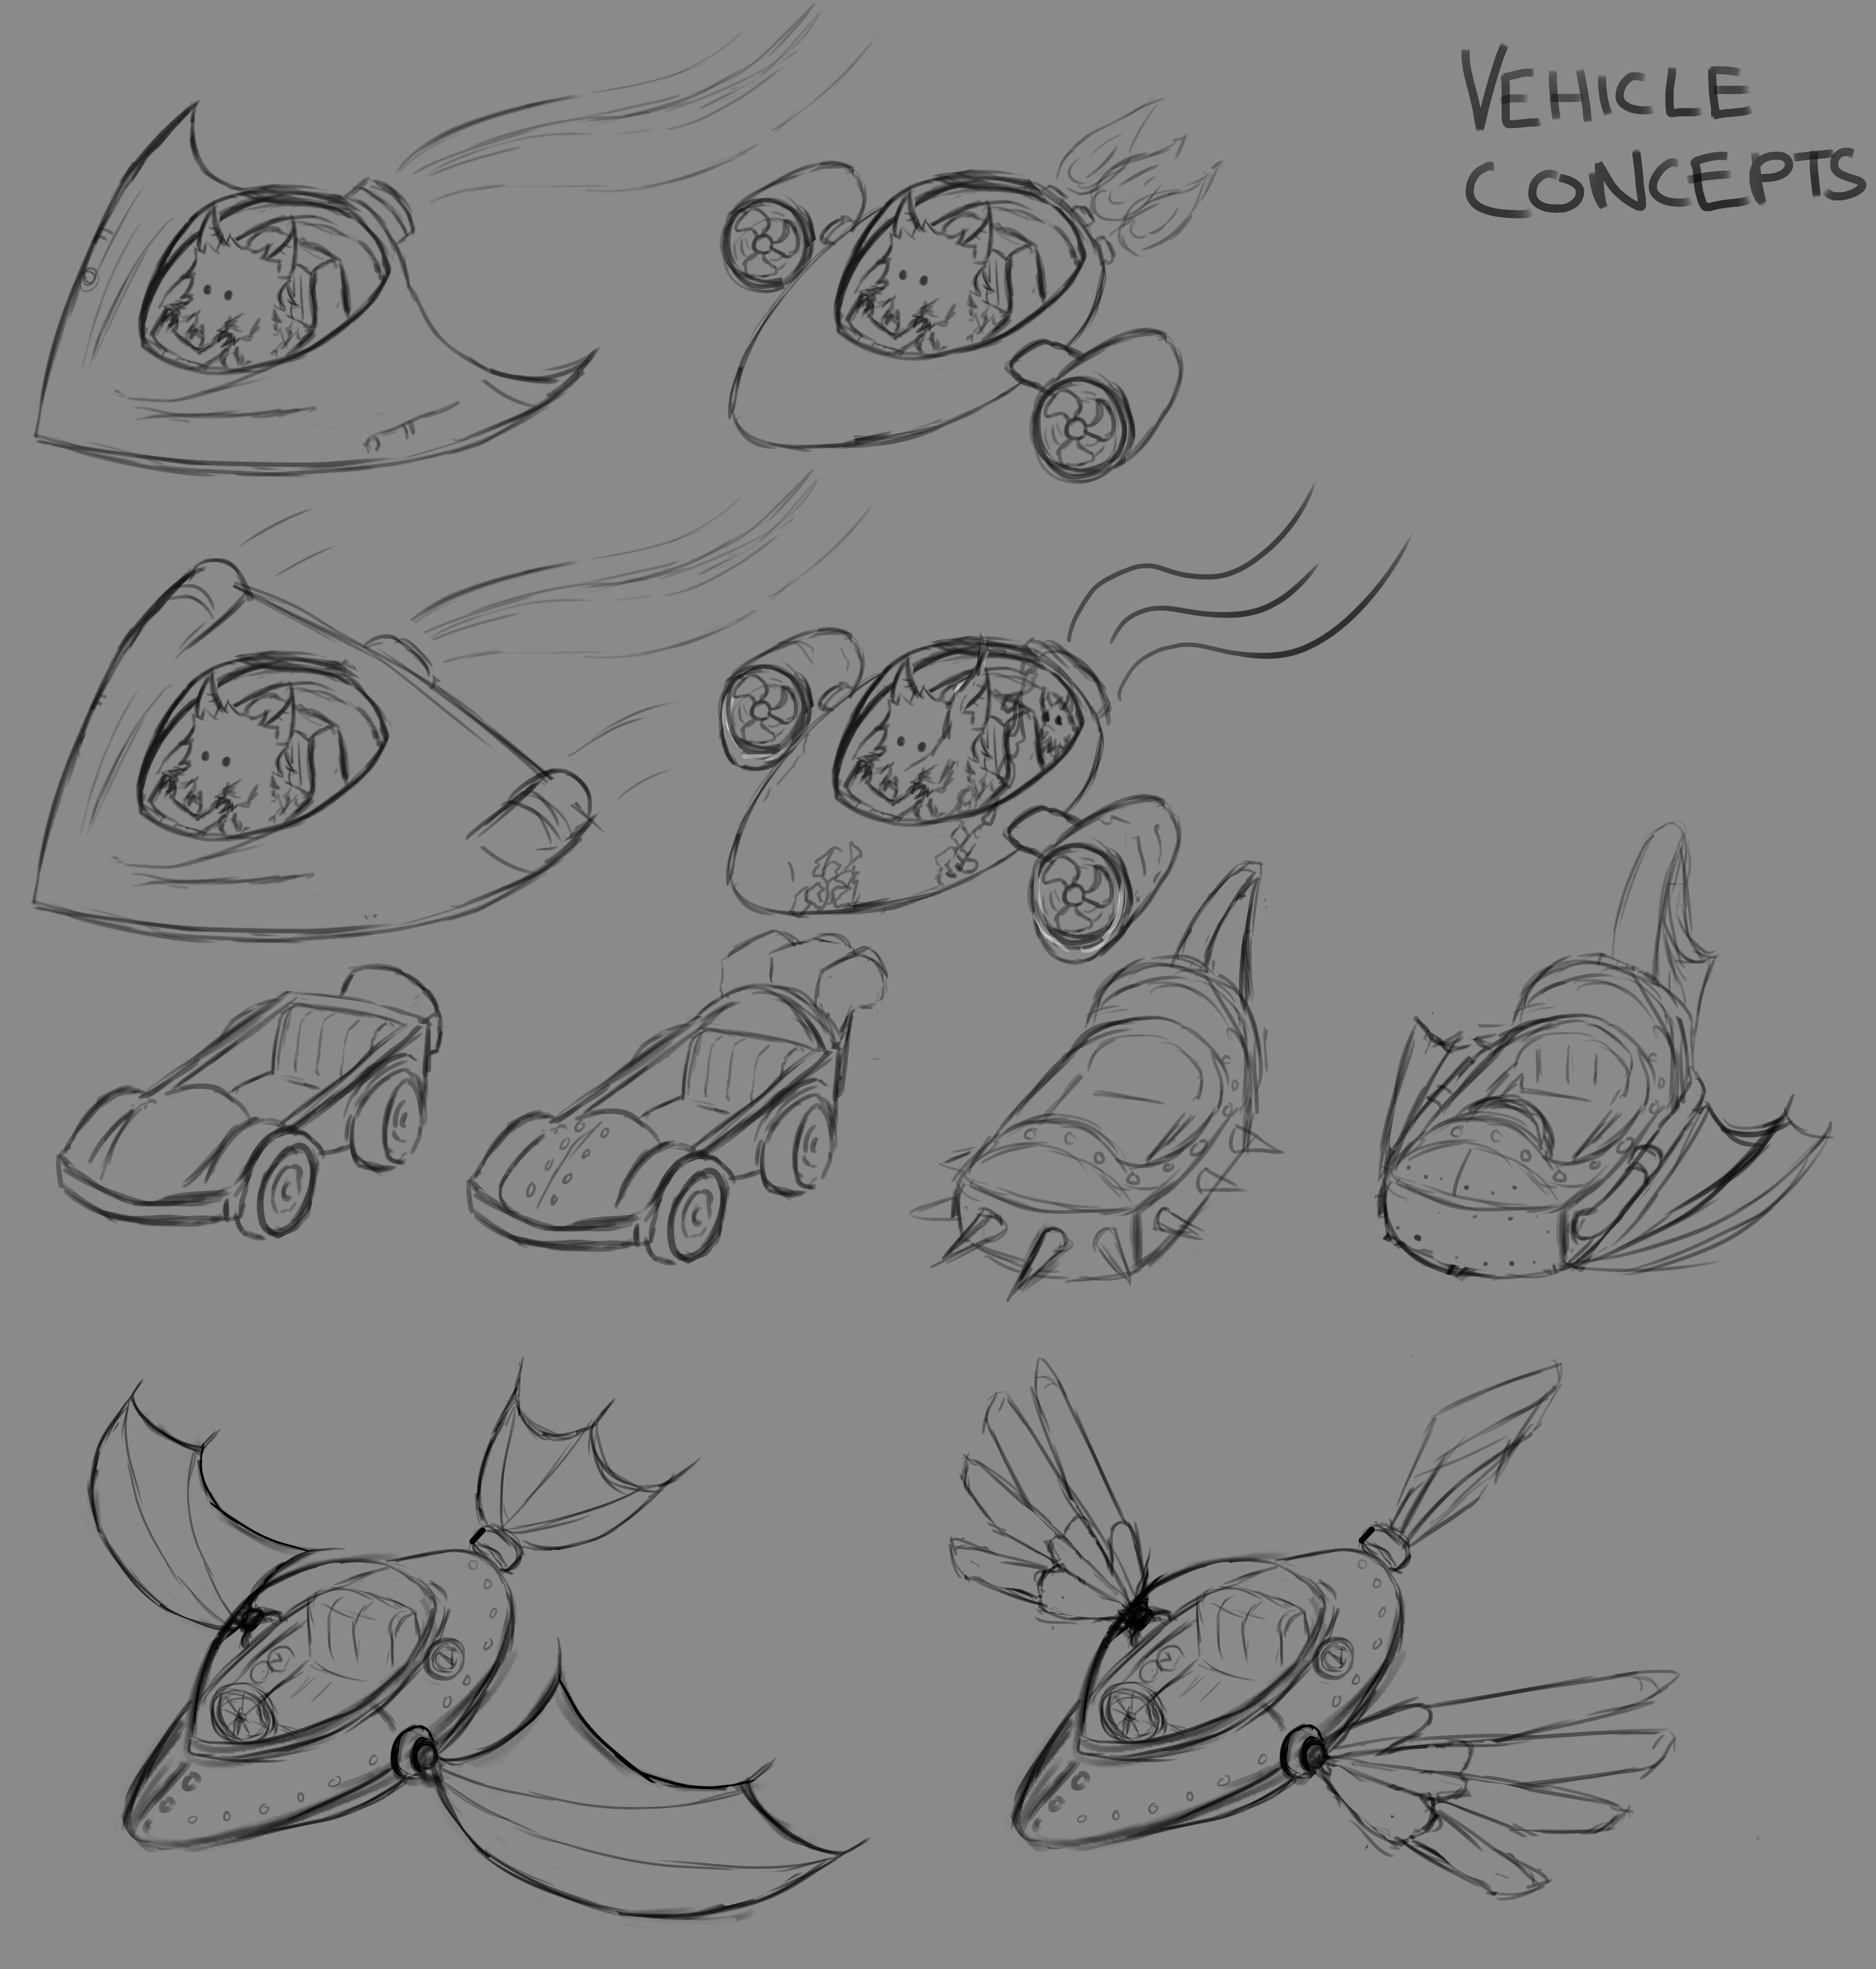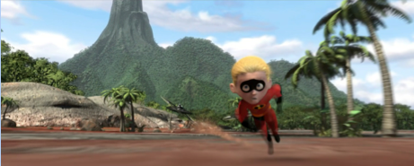

The game will be brightly coloured and have a classic animated look to portray a real life island that you will be racing on. The light colours, along with the ‘natural’ obstacles, will give an open feel to the game even though there it is a closed course. The environment will have a similar environment to the scene in ‘The Incredibles’ where dash is being chased across the island.